Thought Process + project evidence

Project Purpose & Scoping
Highlighted the instruction not to "over-engineer" and the permission to "adjust the brief as fit.”
- Decided to focus on a finished, well-scoped MVP rather than a half-finished, more complex workflow.
- Noted the 4-hour time constraint, so opted to be AI-assisted. Happy to talk through its usage during review.
- Brief is open-ended – “understand the current distribution and characteristics of EV charging points in Central London” - if in the workplace, I would clarify why.
Research & Data Selection
Heavily commercial environment with no single source of truth.
- Research shows providers must expose endpoints through OCPI, but connecting to 10+ individual provider APIs and aggregating them in BigQuery would take too long for this assignment.
- Middle ground… Open Charge Map:
  - Why? Open source, no licensing issues, contains the necessary geospatial/technical data to meet the brief, seemed easy to connect to, sufficient for MVP.
  - Limitations: Being crowdsourced, data quality can vary (duplicates or user-entry errors). Not “live”. Stale data?

Infrastructure Setup
Set up a new Google Cloud Project.
- Created a specific Service Account for the pipeline and assigned the correct IAM roles.
- Generated the JSON key file for local authentication.

Local Development & Testing
Registered an app to get an API key for Open Charge Map and tested the fetch logic locally using Python (requests/pandas).
- Inspected the raw JSON response to select appropriate data fields
  - Opted for ETL vs ELT here to save time in dev. In the professional world, I would usually opt to load the entire dataset to future proof against schema changes
- Ran a quick data quality check (see nimbus_assignment.ipynb):
  - Found postcodes that didn't follow the standard Outward Code + Space + Inward Code" format. No action taken despite being a potential issue for London postcode filtering and plotting.
  - Min/Max of last_verified date shows this data is not accurate. No action taken.
  - Lots of statuses unknown. No action taken.
  - Chargers with max power = 0. No action taken.

Why Open Charge Map? (Strengths)
- Licensing: Data is licensed under ODbL (Open Database License), which permits the use and redistribution of data – ideal for MVP.
- Coverage: It is the largest open global registry. Testing confirmed dense coverage in Central London (~2,200 points in Zone 1), sufficient for this analysis.
- Accessibility: Offers a documented, free-tier REST API with geospatial filtering parameters (Lat/Lon/Radius), allowing for rapid MVP development.
Limitations Identified
- Data Quality - As a crowdsourced dataset, validity varies. Quick analysis found issues listed above.
- Update Frequency - Unlike direct feeds from operators (which are real-time), OCM relies on community updates and batch imports. This results in "stale" data, evidenced by the long tail of last_verified dates found in the analysis.
- Commercial Reality - For a production "Property Intelligence" product, this source serves as a good proxy, but Nimbus would ultimately require direct B2B data agreements with CPOs to guarantee the reliability levels paying customers expect.

Deployment
When happy with the local development script, moved local execution in a Notebook environment to a Google Cloud Function.
- Moved away from the local credentials.json logic and switched to using the Cloud Function's built-in Service Account identity
- Made the function endpoint unauthenticated for this demo, here - https://nimbus-ingest-207053644354.europe-west2.run.app
- Scheduled the job using Cloud Scheduler to run weekly.
- See screenshots below for Cloud Function and Scheduling setup.
- See main.py and requirements.py for Python code in Github repo.

Analysis
- Made BigQuery Views for insights and analysis:
  - Aggregated data by provider and provided info on:
    - Classification of charger speeds into low, medium, fast.
    - Reliability metric (operational points/total)
  - Another View to be used in looker, omitting aggregation by operator
    - Concatenated lat lon for plotting individual charge points
    - Used low, medium and fast classification for plotting

Dashboard
- Pulled the data into Looker studio. Why? Google product, and so easily integrated with Big Query.
- https://lookerstudio.google.com/reporting/e9e3ca50-5934-4533-ad1c-d1922c08c101/page/wGegF
- Simple dashboard showing distribution of charger points, coloured by operator or speed, and with filters for key data dimensions. Page 2 shows the BigQuery View visually.

Key insights
- I took a strategic focus on insights…
- Nimbus can enhance its current property mapping portfolio with EV mappings to:
  - Sell a product specifically for EV developers, enabling them to find prime opportunities
  - Enhance property valuation for owners and developers
- Production challenge + real value:
  - To get real-time reliability for Nimbus clients, we'd likely need to ingest from multiple fragmented sources, direct OCPI connections. The engineering challenge then shifts to normalising 20+ different data schemas into the BigQuery model I built. That normalisation layer is where the real IP value of this project would sit.

Future Production Considerations
- Historical analysis - the current pipeline uses a WRITE_TRUNCATE (Snapshot) strategy. To allow Nimbus to track trends over I would move to WRITE_APPEND with a deduplication view to preserve historical states.
- Security - API keys are currently stored in code for simplicity. In a production environment, these would be managed via Google Secret Manager
- Robustness - if the source API returns corrupt data the current dashboard would empty out. I would implement pre-load checks to halt the pipeline if data quality drops below a threshold.

Appendix

Cloud Function. See main.py and requirements.py for Python code:
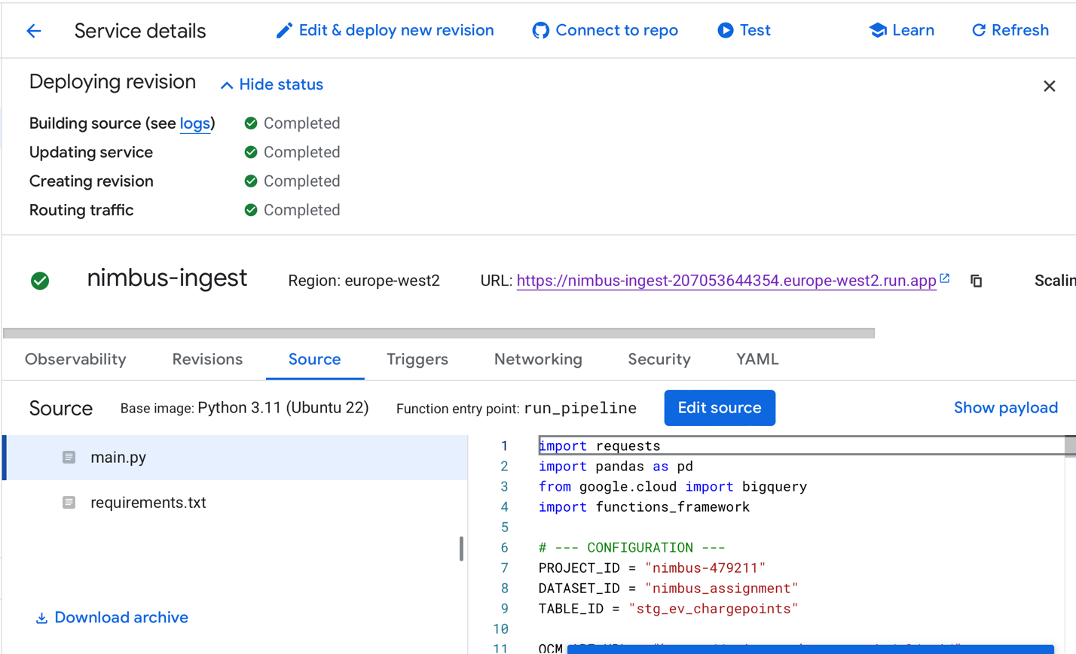

Cloud schedule setup:
